The Extended Super Priority Lien Coverage from FCT can provide added protection for deemed trust claims made by government authorities within 10 years following the discharge of the mortgage, up to a maximum of $500,000.

Here’s a scenario to illustrate how it works:
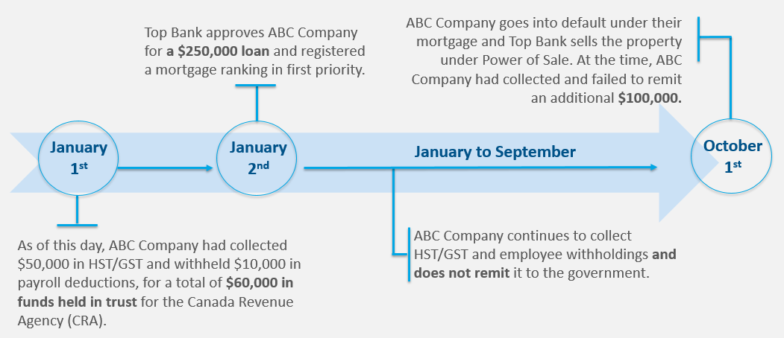

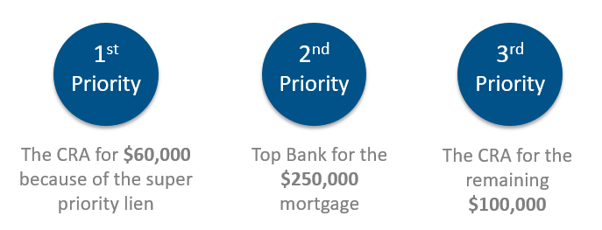
In this scenario, what is the priority?
Top Bank recovers what they can from the sale proceeds after power of sale proceedings but there was a shortfall given the outstanding balance of the mortgage was still high. Because FCT title insured Top Bank’s mortgage to ABC Company, Top Bank is covered for up to $60,000 for the lien for the deemed trust owing prior to the effective date of the policy*.

Historically, Top Bank’s coverage for the $60,000 owed to CRA ends once the mortgage is discharged from title. With FCT’s NEW Extended Super Priority Lien Coverage, the lender’s existing protection continues for another 10 years after the mortgage is discharged.
For more information about the Extended Super Priority Lien Coverage, please contact your FCT Business Development Manager.

